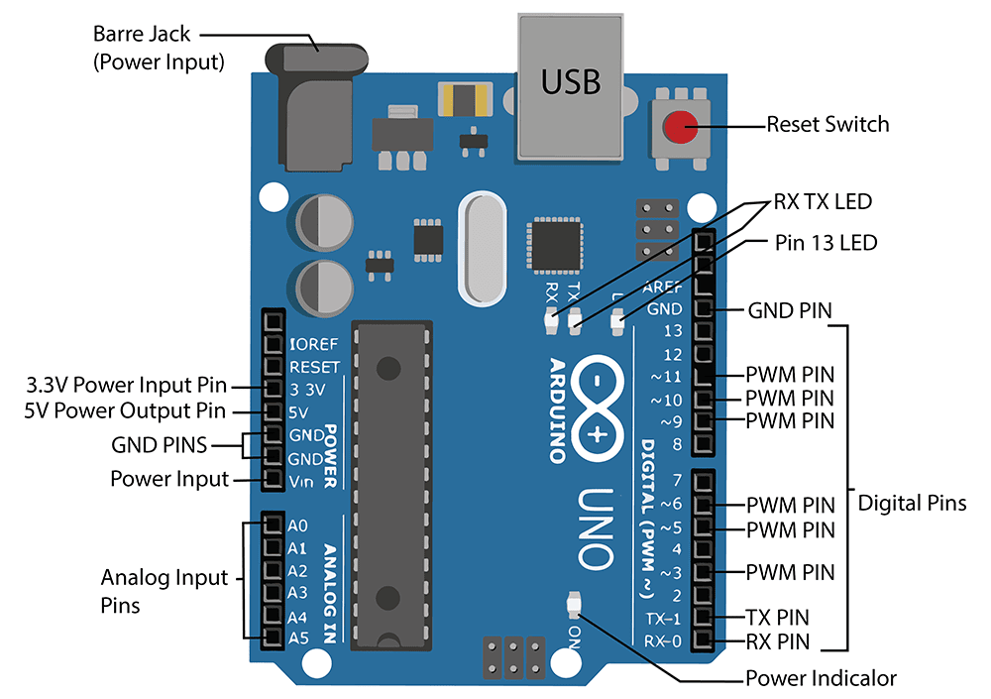Arduino Uno :

Arduino UNO is a microcontroller board based on the **ATmega328P**. It has 14 digital input/output pins (of which 6 can be used as PWM outputs), 6 analog inputs, a 16 MHz ceramic resonator, a USB connection, a power jack, an ICSP header and a reset button. It contains everything needed to support the microcontroller; simply connect it to a computer with a USB cable or power it with a AC-to-DC adapter or battery to get started.

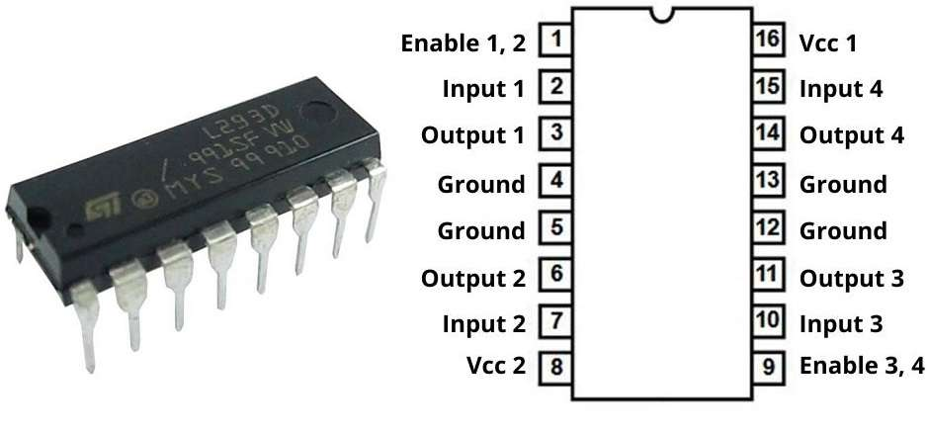L293D Motor Driver :

16x2 LCD Display :

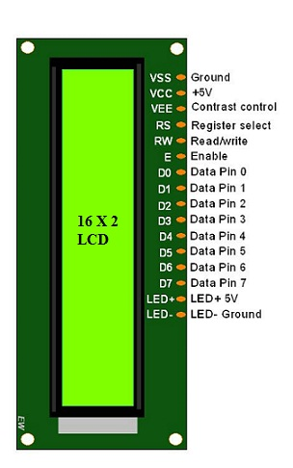

pH sensor Module :

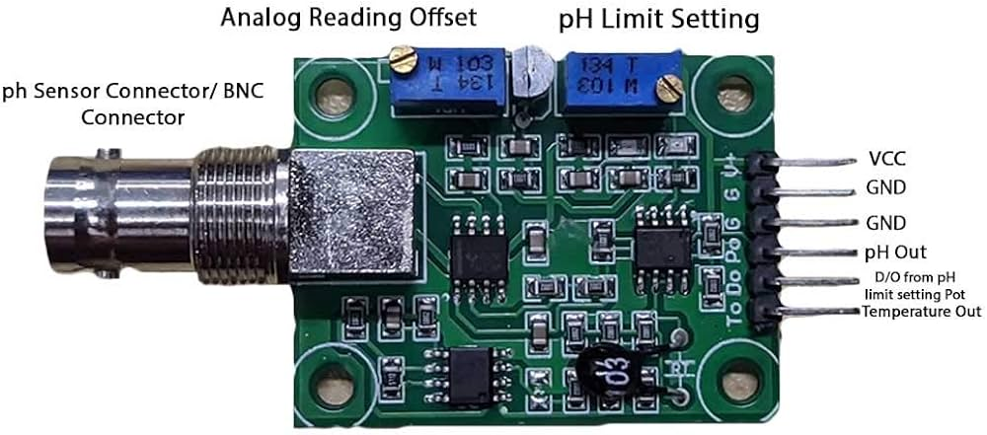

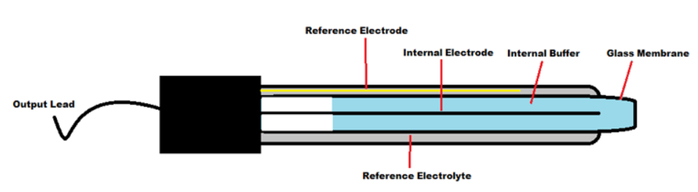

* 3.7v Battery
* LM2596 Buck Converter
* Switch
* 10k pot
* 1k resistors
* LED
* 6V water Pump
* Breadboard
* Wires